SECAS Steering Committee
Operational Guidelines

BACKGROUND

The Southeast Conservation Adaptation Strategy (SECAS) is a regional conservation initiative covering the Southeastern Association of Fish and Wildlife Agencies’ (SEAFWA) geography that includes the Southeastern U.S. states and two territories in the Caribbean. SECAS was started in 2011 by the state directors of SEAFWA and the US Fish and Wildlife Service (Service), and includes participation by the federal agencies of the Southeast Natural Resources Leaders Group (SENRLG). SECAS emerged in response to the unprecedented challenges facing conservation of natural and cultural resources, including human population growth, energy development, and climate change. These challenges are too daunting for any one organization to overcome alone, but they present an opportunity for collective action around a shared plan.

SECAS was created to strengthen collaboration among agencies and organizations responsible for natural and cultural resources in the Southeast, while honoring differing agency responsibilities and authorities. SECAS was also established to ensure that individual sub-regional planning efforts, initially developed through the Southeastern Landscape Conservation Cooperatives (LCCs), contributed to a coordinated regional strategy to define the landscape of the future to sustain fish and wildlife in the Southeast, specifically described as “an ability to add things up ecologically on the landscape.”

SECAS serves as a regional forum for collaboration and as a science and information hub to inform conservation decisions across jurisdictions. SECAS works to design and achieve a connected network of lands and waters to benefit ecosystems, species, and people. SECAS tracks regional metrics of Southeastern ecosystems to report annually on progress toward achieving the SECAS Goal of 10% improvement in ecosystem health, function, and connectivity by 2060. The primary product of SECAS is the Southeast Conservation Blueprint, a living, spatial plan that identifies the most important areas for conservation and restoration across the region.

The initial governance structure of SECAS grew out of the LCCs and their networks of steering committees and partnerships. Since 2017, those networks were dissolved or otherwise transitioned, resulting in reduced directional and collaborative guidance to SECAS. In 2019, SEAFWA Directors established an interim steering committee to oversee the actions of SECAS, and permanent status for the committee was established in 2021 (proposed).

COMMITTEE GOAL

The SECAS Steering Committee shall be the Director-level leadership forum for consideration, discussion and deliberation of the major actions and accomplishments of the SECAS partnership. The Steering Committee will serve as a conduit to receive and deliver information on SECAS and collaborative landscape-scale conservation generally among the Committee members, other SEAFWA Directors, federal agency partners, and with the broader conservation community.

COMMITTEE CHARGE

The Steering Committee shall provide oversight and strategic direction to SECAS to strengthen collaboration for landscape-scale conservation while honoring differing responsibilities and authorities among the participating agencies and organizations. The Steering Committee will work with the SECAS Coordinator and other SECAS staff to provide strategic direction to the designated SECAS Points of Contact working to support, promote, and improve the products, services, and accomplishments of SECAS. Steering Committee members will communicate the priorities and actions of SECAS among SEAFWA agencies, federal agency partners, and other partner organizations.

MEMBERSHIP

The SECAS Steering Committee shall comprise five (5) SEAFWA Directors, appointed by the President, to serve a two-year term following appointment. Steering Committee members may serve unlimited consecutive terms. In addition, the Committee shall include one (1) ex officio member who is in the position of the Southeast regional director of the US Fish and Wildlife Service (Service), who represents the Services’ landscape conservation priorities and shall also serve as liaison from SECAS to the federal Southeast Natural Resources Leaders Group.

MEETINGS

Meetings of the Southeast Conservation Adaptation Strategy (SECAS) Steering Committee shall be held in conjunction with the Annual SEAFWA Conference and at other times and places as necessary and called for by the Committee Chair. Participation in meetings by telephonic or other electronic communications means will be allowed and encouraged.

The Committee’s charge extends to oversight and strategic direction of SECAS. Decision-making by the Committee, when required, shall be by consensus of the members in attendance.

OFFICERS

The SECAS Steering Committee shall have a chairperson as the sole appointed officer. The Chair may serve unlimited consecutive terms and shall be appointed and/or re-appointed by the President following the spring meeting and prior to August 1 annually.

DUTIES of OFFICERS

The Committee Chair’s responsibility shall include, but not be limited to:

- Scheduling committee meetings and preparation of agendas, including notification to committee members, the SEAFWA Executive Secretary and others as appropriate;

- Conducting committee meetings in a manner to best accomplish the charge of the committee. Chairs have great discretion in running meetings but must ensure procedures and rules sufficient to properly address the issues and matters being considered and the soundness of committee recommendations.

- Providing written and verbal reports of committee meetings and recommendations to the SEAFWA Directors, Executive Secretary and others as appropriate. Written reports shall follow a report outline as attached and made a part of these guidelines.

- Coordinating committee issues, actions and recommendations with the other SEAFWA committees which have overlapping responsibilities or mutual interests;

- Designing and implementing a leadership continuity plan by providing for and developing potential committee chairs among respective committee members. Plan implementation may be facilitated through a combination of work assignments, leadership appointments and delegation of responsibilities so as to adequately provide a continuity of quality leadership in the absence of existing chair.

- Maintaining files and other documents of historical or other significance to the committee and forwarding to succeeding chairs;

- Selecting a designee to assume the duties of the Chair when the appointed Chair is temporarily unable or unavailable to carry out such duties; and

- Other functions as may be necessary, including communicating periodically with an assigned Director-liaison (if applicable) to fulfill the duties and responsibilities of the committee.

The SECAS Geography
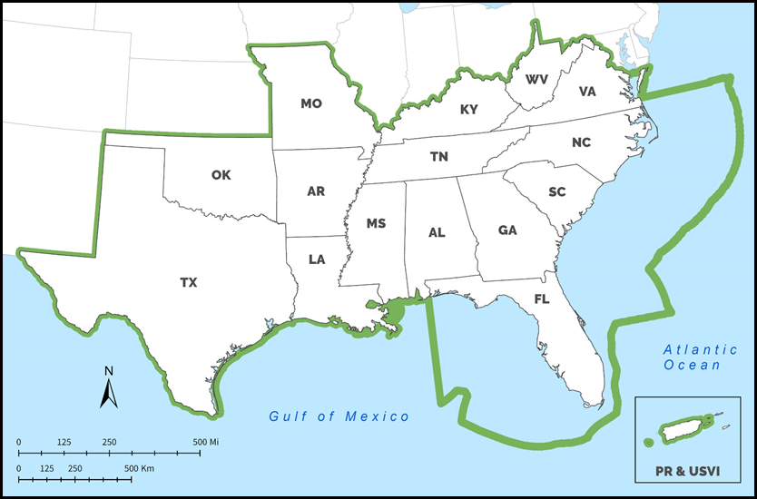

SECAS governance and operational structure March 2021
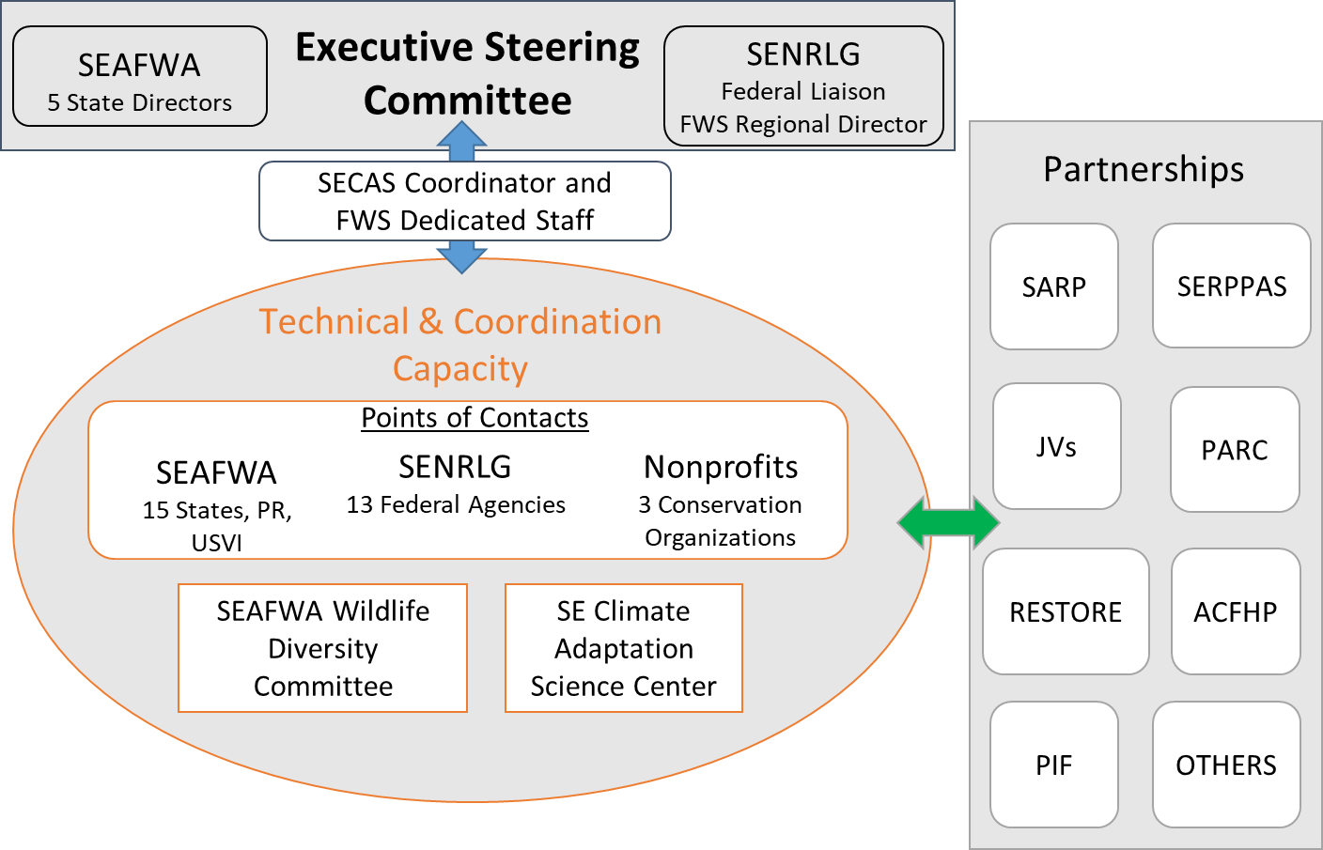

ACFHP Atlantic Coastal Fish Habitat Partnership
FWS U.S. Fish and Wildlife Service - Interior Regions 2/4
JVs Migratory Bird Joint Ventures
PARC Partners in Amphibian and Reptile Conservation
PIF Partners in Flight
POCs SECAS Points of Contact
RESTORE Gulf Coast Ecosystem Restoration Council
SARP Southeast Aquatic Resources Partnership
SEAFWA Southeastern Association of Fish and Wildlife Agencies
SECAS Southeast Conservation Adaptation Strategy
SENRLG Southeast Natural Resources Leaders Group
SERPPAS Southeast Regional Partnership for Planning & Sustainability

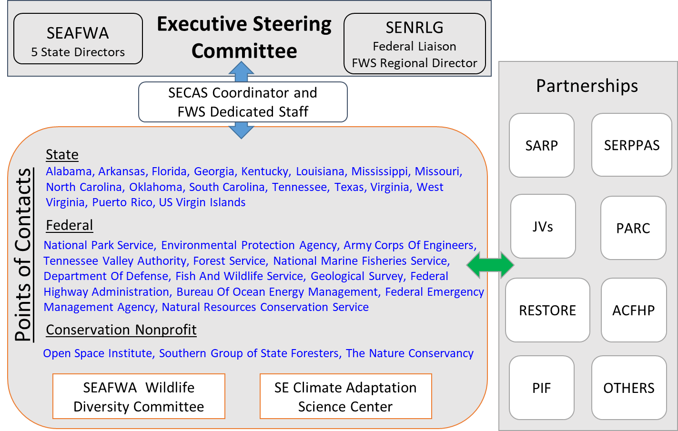

SOUTHEASTERN ASSOCIATION OF FISH AND WILDLIFE AGENCIES

Committee Report (Insert Committee Name)

Chair (Insert Name),

Meeting of (Insert Date)

City, State

Meeting convened (insert start time);

Chaired by (insert name);

Committee Members Attending: (list by name)

Scheduled Discussion Items: (provide bulleted list with brief annotation about nature of each discussion)

Other Discussion Items: (provide bulleted list with brief annotation about nature of each discussion)

Action Items and Recommendations: (provide brief subject statement and specific action recommended)

Committee Recommendation for Chair: (insert name)

Meeting adjourned: (insert time)

List of current committee members and contact information: (attach listing)

List of interested participants and contact information: (attach listing)

List and description of active committee members: (describe)

Submitted by: (Insert Committee Chair name)

