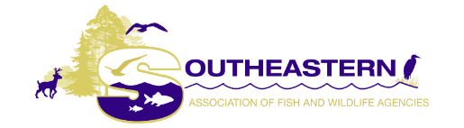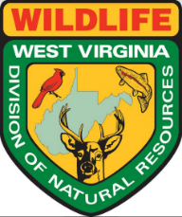

With Appreciation to the

West Virginia Division of Natural Resources
Wildlife Resources Section

WHEREAS, the 2021 Spring Director’s Meeting of the Southeast Association of Fish and Wildlife Agencies (SEAFWA) was held virtually on March 2, 2021 by our host state, Wild and Wonderful, West Virginia; and,

WHEREAS , the SEAFWA President, Mr. Paul Johansen, the West Virginia DNR-Wildlife Resources Section Chief, and his talented staff accepted the challenge of providing an excellent ‘virtual’ opportunity during the COVID-19 Pandemic, and the meeting provided for the exchange of valuable information among the attendees with thought-provoking discussions on items of interest and mutual concern to the state agency members attending the SEAFWA Spring Directors Meeting; and,

WHEREAS, the beautiful state of West Virginia is located in the Appalachian region where some of the most rugged land in the country is found, with rolling mountains, hills and valleys earning it the nickname - The Mountain State - and being well-known for its unmatched recreational outdoor activities, including hiking, mountain biking, skiing and whitewater rafting and as well as having the friendliest folks in the country (including its Wildlife Resources Chief, who has become known as “the guy who can’t say ‘no’” to a request for help), and

WHEREAS, our cordial hosts at the West Virginia DNR-Wildlife Resources Section, goWILD West Virginia, are famous for protecting and managing their state’s fish and wildlife resources for the enjoyment of all its citizens by protecting habitat and providing diverse opportunities for recreation, conservation and education; and where school children are educated about WV wildlife through arts and crafts, at home games and outside activities; where ‘French Creek Freddie’ predicted an early spring this year; where WV hunters harvested 106,861 deer during the fall-winter season; where their Law Enforcement Section offers Hunter Ed and has the foresight to offer classes designed for hunters with special needs; where their Wildlife Diversity Program offers publications on mushrooms, butterflies, wildlife viewing, and songbirds; and where dozens of fishing tournaments are held around the state from February through August; and

WHEREAS, the Great State of West Virginia – The Panhandle State – now features a new black bear license plate; is home to some of the nation’s best trout streams located at Shavers Fork and Elk River; where outreach efforts through their Governor’s Youth in the Outdoors and Becoming an Outdoorswoman Programs are successfully introducing participants into the joy of hunting, fishing, and wildlife watching; where the Monongahela National Forest covers nearly a million acres of land; where more than 350,000 hunters took to West Virginia's woods this year; and where West Virginia is famous for their Roadkill Cook-Off, Wild Game Festival, Squirrel Fest, and the ever popular Critter Dinner – celebrating 47 years of specialized exotic cuisine including Gator, Wild Boar, Venison, Elk, Opossum, and Buffalo and where visitors can sample squirrel gravy, teriyaki-marinated bear and deer sausage; and
WHEREAS, this 2021 Spring Director’s Meeting of the SEAFWA Directors has facilitated useful discussions regarding the balance of wildlife with the needs of the public using the best science available to meet the challenges necessary for the sustained success of those renewable resources.
NOW, THEREFORE, BE IT RESOLVED that SEAFWA-Making the Southeast a Better Place for People, Wildlife, and Fish-expresses its sincere gratitude and warmest appreciation to the Great State of West Virginia and the West Virginia Division of Natural Resources, Wildlife Resources Section for hosting an outstanding 2021 SEAFWA (Virtual) Spring Director’s Meeting.

ADOPTED by SEAFWA in official session on March 2, 2021.

