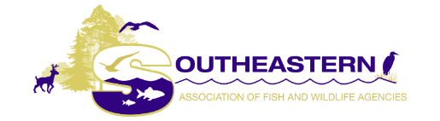
IN APPRECIATION of the
Missouri Department of Conservation

WHEREAS, the 2020 annual conference of the Southeastern Association of Fish and Wildlife Agencies was held on Monday, October 26 to Wednesday, October 28, 2020 as a virtual meeting hosted by the Missouri Department of Conservation (MDC); and,

WHEREAS, the annual conference of more than 500 representatives from state and federal agencies, organizations, universities and private wildlife research groups, scientists and enforcement personnel, is a forum for the exchange of ideas and critical information regarding the management and protection of fish and wildlife resources primarily in the southeast and where abundant discussions, both informal and formal, regarding wildlife resource management and challenges for the sustained success of renewable resources is discussed; and,

WHEREAS, the Missouri Department of Conservation, our gracious hosts, have provided an excellent virtual meeting for the SEAFWA members and, the MDC, has provided a unique opportunity to meet online as we conducted the business of the SEAFWA; and

WHEREAS, MDC Director Sara Parker Pauley and her talented staff have provided an excellent opportunity for the exchange of important information among virtual attendees and stimulating discussion of items of mutual concern and interest where we might connect our passion and purpose as we recharge ourselves to boldly embrace opportunities to build on a solid history of conservation success;

NOW, THEREFORE, BE IT RESOLVED that SEAFWA expresses its sincere gratitude and warmest appreciation to the Missouri Department of Conservation for hosting an outstanding 2020 SEAFWA 74th Annual Fall Conference.

ADOPTED by SEAFWA in official session on October 27, 2020.

